A Beginning
St. Ann Catholic Mission

535 West First Street, Palisade, CO 81526 pastor@Stannspalisade.org
Parish Office (970) 464-5024 Parish Hall (970) 464-5157 - www.ihmgjt.org

“We of St. Ann Parish, being of the family of Christ, commit our lives to Gospel values in the
community in which we live and worship. Through Eucharist, Spiritual development, Evangelization and Ministry, we show that we love and serve all persons as brothers and sisters in Christ.”

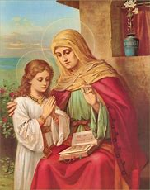

Hrist Jesus is the 74
AugusSeptember 2, 2018

March 12, 2023 Third Sunday of Lent
Meditation
In Giving We Receive
The third way to celebrate Lent is through almsgiving. This idea gives an opportunity to retell a familiar story.
Once upon a time, a beggar asked alms at the mansion of the lord. The servants tried to send him away saying that they had nothing to give. The beggar then asked if he could boil some water to make soup for the stone he carried. Thinking this was an unusual request, the servants provided a saucepan, water, and a spoon. The beggar sampled his soup and declared it could use a little salt and pepper. The servants were really into it now, so they shared some of theirs. The beggar stirred it with a flourish and when he tasted it, he thought it might need a little meat and some vegetables. These were supplied. Again, upon tasting the mixture, he accepted a bit of sauce. Then they all tasted it, declared it delicious and shared together their meal of stone soup. Let us not be tricked into sharing what we have but offer it willingly. The gesture will come back to us a hundredfold.

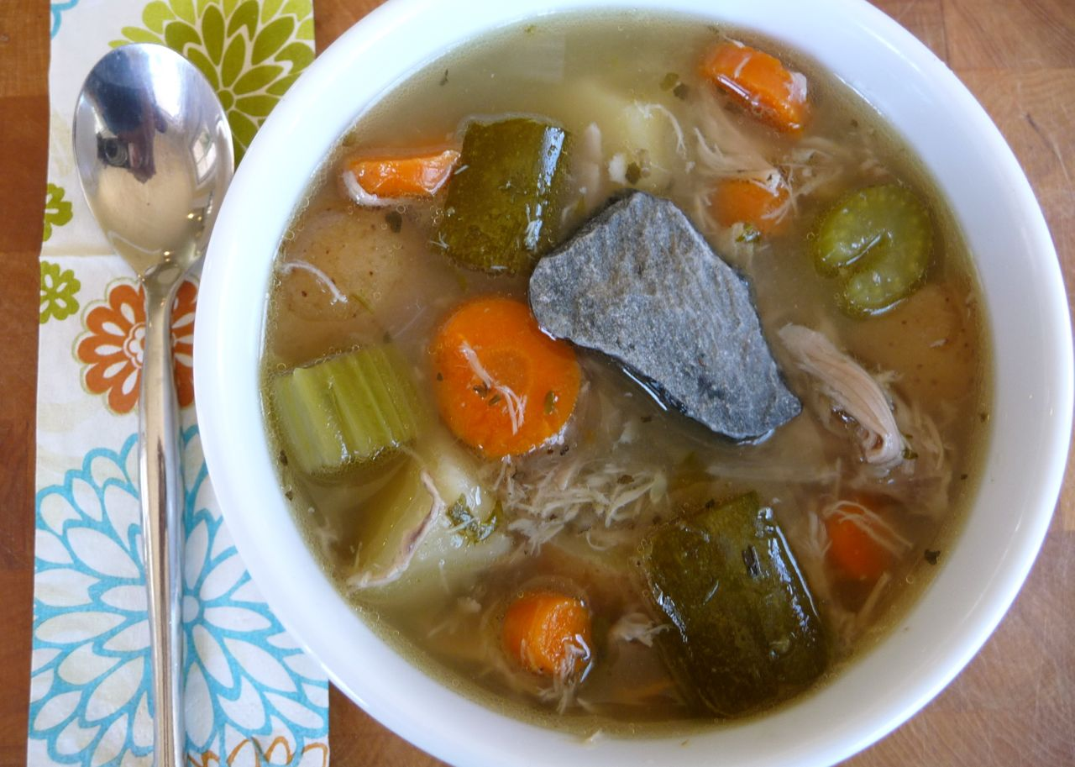

.

Sunday Mass:
9:15 a.m.
(Divine Mercy Chaplet: 8:45am, first Sunday)
(Rosary: 8:45 am All other Sundays)
Tuesday Mass:
10:30 a.m. Mass
Holy Day Masses:
Times to be determined.
Adoration:
First Friday of each month 12:00-1:00 pm

Reconciliation/Saturday:
2:00 to 3:30 p.m.
(Immaculate Heart of Mary,
26½ & H Roads, Grand Junction)
Parish Staff:
Pastor: Fr. Chrysogonus Nwele (970) 242-6121
Parochial Vicar: Fr. Selva Soosai
Deacons Luke Konantz, Leo Truscott
Bookkeeper:
bookkeeper@ihmgjt.org
Business Administration:
Rick Aluise, raluise@ihmgjt.org

Pastoral Council

Linda Hall, Judy Cole, Gaynel Abadie,
Fred Binggeli, Patty Kornely, Rob Scribner
Finance Committee
Ron Gilligan, Brian Kaufman

To start the prayer chain, please call Mary Beth Gilligan, 970-409-8100. To schedule communion for the homebound, contact Jill, 970-464-7740

Welcome to all visitors who are worshipping with us today! If you are a newcomer to the area, please stop by the Hospitality Room and pick up a Registration Form.

Parishioners… complete the “Change Form” if you’ve had a recent change in information, for example, telephone number, address, e-mail, family composition, etc.

Parish office hours: 9:00am-12:00pm. Tuesday
970-464-5024

MASS INTENTIONS
Mass Intention, Sunday,
By
Tuesday, March 17th, 2020
By

St. Ann Mission Weekly Financial Update

We’re grateful for the compassion, generosity and hope with which God blesses our St. Ann family.
Collections for Sunday, March 15 2020, Total Offering: $
Collections for Capital improvements: $
DMF: Our goal for 2020 is $14215.
Amount pledged $5635.00, amount paid $4584.00. 40% pledged toward goal!

There are numerous opportunities for parishioners of St. Ann’s to help make a difference in the lives of people in the Grand Valley. Some of these opportunities include:
- Child & Migrant Services, 721 Peach Avenue, Palisade. Karalyn Dorn, director. Phone: 234-9460
- Mesa County Migrant Ministries Community Thrift Shop, 721 Peach Avenue, Palisade.
- Grand Valley Catholic Outreach, 245 S. First Street, Grand Junction. Sr. Karen Bland, OSB, director. Phone: 241-3658.
- Grand Valley Peace & Justice, 740 Gunnison Ave, Grand Junction. Julie Mao, director. Phone: 243-0136.
- Holy Family Catholic School, 786 26½ Road, Grand Junction. Jake Aubert, principal. Phone: 242-6168.
(Development Office, Phone: 242-3292).
- Newman Center at Colorado Mesa University, call 242-6121.

Liturgical Roles for Next Week
Mass Intention Sunday,
By
Tuesday,
By

Ministry Schedules are posted in the Hospitality Room.
Remember: Please find a replacement if you can’t be here for Sunday
Celebrant:
Extraordinary Ministers of Holy Communion:
Lectors: 1st: 2nd:
Server: Greeters:
Environment: Leslie Piquette, Mary Cowan
Musicians:
Coffee Hosts: Ushers:
Counters: Sacristan:

Gratitude Corner:
To Gaynel who is teacher’s pet!

Although we have some time before this needs to happen, we are looking for someone to prune the roses around the church. Please see Jill if you would like to do this.

Lenten dates to remember:
- Bishop Baron’s sessions on The Mass, every Tuesday during Lent at 11:30am.
- Stations of the Cross, every Friday at noon.
- All day confessions at IHM, 9am-6pm.
- “Celebrate Laetare Sunday with waffles” potluck brunch. Waffles provided. Sign up in the narthex.

Today’s Mass is in remembrance of deceased members of the Huber family by Mike & Ruth Partyka. Tuesday’s Mass is in remembrance of Dee Farney by Anni Vilches.

Liturgical ministers for March19th:
- Lector: Jake
- EM: June, Linda, Patty
- Ushers: Darius, Mary
- Counters: Barb, Gina
- Coffee Host: Judy, Linda
- Musicians: Keyboard by committee

The Beatitude for March is “blessed are the pure in heart...” Mary teaches us purity and modesty through her life. How can we be like her?

Catholic Daughters Mount of the Holy Cross #941 is hosting a fundraising party through Mary Kay Cosmetics to support the State Convention hosted by the Grand Valley in June. For information on how to participate, please see the flyer in the narthex or any CDA member.

PARISH HAPPENINGS
St. Ann Mission March 12

15
St. Ann Mission May 20th

april
, 2017

Please remember the following in your prayers: Bethel Davis, Mary DuFresne, Diana McDermott, Patsy Ray, Carol and David Card, Janet Connors, Tom Foral, Fe Aigner, David Castillo, Sylvia Norwood, Rick Bowen, Elisa Castillo, Macie Bridges, Jennifer Johnson, Teresa Vale-Cruz, Jeanine Linster, Brian Marrotte, Daniel DuFresne, Jim Kapcar, Brian Tennal, Judy Skirbina, Roger Jones, Angelo Martino, Pete Rygwalski, Jonathan Aluise, Laura Triest, Roland Drapeau, Kevin Tennal, Ivy Freedmon, Mimi Philbrook, Phil Farney, Matt Drapeau, Kathy Stelly, Patsy Wanstedt, Ronnie Dufrane, Jordan Aluise, Marjory Donahue, Leo Stewart, Chuck & Frances Durand, Kaitlyn King, Charles Neuner, Louise Griffith, Barb Griffin, Sandy Miranda, Kelly Mattson and Margaret Talley.

Remember that we are observing a centering minute before every Mass.

Please join us for Stations of the Cross every Friday during Lent. There is a signup sheet in the narthex if you would like to volunteer to lead the Stations.

Lent meditation books and rice bowl boxes are available for you in the narthex.

Remember to do what it takes to protect your parish family from illness.
St. Ann’s bulletin online. Go to IHM’s main page (ihmgjt.org). Click on the St. Ann’s link.
If you have anything for the bulletin, please contact Jill, 464-7740 or shoediva.palisade@gmail.com or pastor@Stannspalisade.org.
Donations for the valley wide shrine are being matched dollar for dollar.
Go to guadalupeshrinegv.org.

